CASE STUDY 8: SECURE ATM BANKING SIMULATOR AND TRANSACTION AUDIT SYSTEM
1 PROBLEM STATEMENT
Design and implement an automated teller machine (ATM) simulation module that handles secure PIN authentication with limited attempts, validates numerical input constraints (multiples of currency denominations), enforces financial limits (maximum deposit ceilings, per-withdrawal caps, daily withdrawal limits, and minimum balance maintenance), and generates a detailed transaction summary log.
2 OBJECTIVES
- Enforce secure 4-digit PIN authentication with a maximum attempt limit before card blocking.
- Validate that entered amounts are positive numerical values and strict multiples of specified currency units (e.g., multiples of 100).
- Enforce multi-tier withdrawal and deposit rules (per-transaction caps, daily limits, minimum balance reserves).
- Maintain a chronological log of all successful transactions.
- Generate an executive reconciliation statement tracking total deposits, total withdrawals, and final account balance.
3 KEY ASSUMPTIONS
Initial balances, PIN credentials, and transactional thresholds are predefined configuration constants. Multiples and constraints apply universally to all cash deposit and withdrawal interactions.
4 ALGORITHM
- Initialize security configurations (CORRECT_PIN, MAX_PIN_ATTEMPTS, limits, and balances).
- Prompt user for PIN authentication; allow up to MAX_PIN_ATTEMPTS before terminating.
- Present an interactive menu for Deposit, Withdrawal, Balance Inquiry, Transaction Summary, and Exit.
- For deposits and withdrawals, validate input via get_amount ensuring positive numeric values and multiples of 100.
- Check transaction-specific rules (max limits, daily caps, minimum balance) and update account state upon success.
- Record successful transactions and print a detailed summary log upon request.
5 FLOWCHART REPRESENTATION
Plaintext
[Start] -> [Authentication Loop: Verify PIN] -> [Authenticated? Yes: Show Menu | No: Block Card & Exit]
-> [User Choice Selection] -> [Option 1: Deposit / Option 2: Withdraw]
-> [Validate Amount (Positive & Multiple of 100)] -> [Check Operational Limits & Balances]
-> [Success? Update Balance & Log Transaction] -> [Option 4: Print Summary Log] -> [End]
6 PSEUDOCODE
Plaintext
FUNCTION login():
FOR attempt FROM 1 TO MAX_PIN_ATTEMPTS:
IF entered_pin == CORRECT_PIN: RETURN True
RETURN False (Card Blocked)

FUNCTION withdraw():
amount = get_amount()
IF amount > MAX_WITHDRAW OR withdrawn_today + amount > DAILY_LIMIT OR balance - amount < MIN_BALANCE:
REJECT with appropriate error message
ELSE:
balance -= amount, withdrawn_today += amount
LOG transaction ("Withdrawal", amount, balance)

FUNCTION main():
IF NOT login(): RETURN
WHILE True:
Display Menu and process user choice
8 TEST CASES
Operation / Action | Input Details | Expected Outcome | Status / Failure Message
TC-01: Secure Login | Enter PIN: 1234 | Success | Login successful!
TC-02: Invalid PIN | Enter PIN: 9999 (3 times) | Blocked | Card blocked. Too many wrong attempts.
TC-03: Valid Deposit | Deposit Amount: 2500 | Accepted | Balance updated successfully
TC-04: Non-Multiple Amount | Withdrawal Amount: 450 | Rejected | Amount must be a multiple of 100.
TC-05: Minimum Balance Breach | Withdrawal Amount: 9800 | Rejected | Insufficient funds! You must keep a minimum balance...
9 OUTPUT SCREENSHOTS
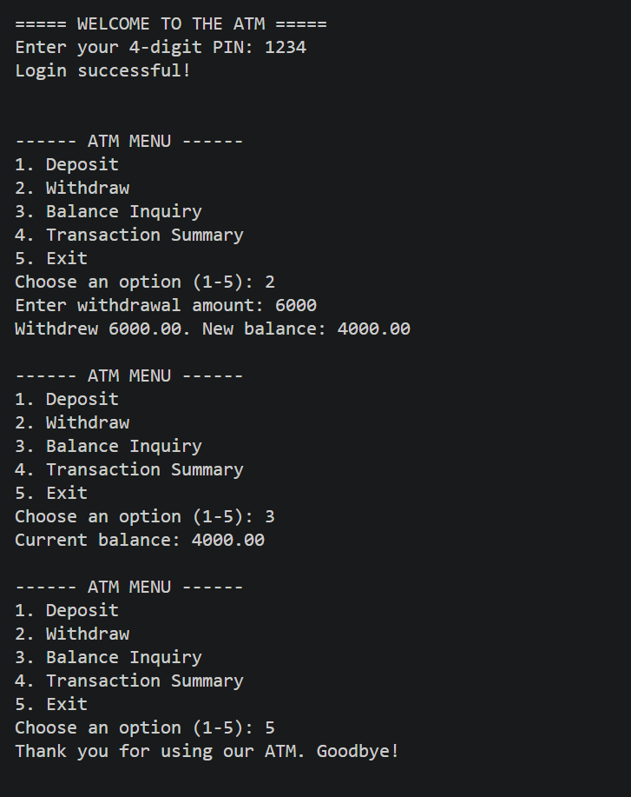
10 CONCLUSION
The secure ATM simulator successfully manages multi-factor authentication, enforces strict cash limit validation rules, and maintains accurate financial audit logs for banking operations.

